Drishtee Gram Mitras’ Improvement and Success Story of Uttarkashi Dunda block.

1-Introduction:- As we now that our great India is mainly Called country of villages because large part of population living in rural area. In the reference of rural India 85% part of population is not developed by different way for ex. Agriculture, economic status, education, health etc. So all of these shortcomings they have needs specially for different above mentioned related factor for both Villages and Villager.
The concept of need may be defined by different way for development of both villages and villagers. On the present time central government launched the ambitious scheme Digital India for development of rural and urban area, and many other schemes launched for development of the population of rural India and individual villagers, Annual Budget issued/released for supporting against fulfill every schemes by central and state government. But annual Budget for every schemes does not utilized and used properly so everywhere seen inequality, still needy person could not take advantage of the schemes in spite of fully support of government also.
So this inequality can be bridge a gap by information, therefore our company “Drishtee Foundation” launched a project “Soochna Aapke Dwar” in Uttarakhand(Uttarkashi dunda block).
For Execution of this project “Soochna Aapke dwar” we built a team of Volunteers to give information and awareness for Individual and community basis according needs.
Some of the special features of developing and good success of information systems given below-
1:- Gram Panchayat Misar Gown and Bhatwari Dhanari(Drishtee Gram mitra- Umashankar).

In Gram panchayat Misar gown mr. umashankar working as Volunteer(DGM) for giving proper information according needs in villages. And in the reference of proper information mr. umashankar first check out by door to door survey and then find out need. Further in this process he find out that the villager mr. kiriti bhushan who is disabled by ear and cannot speak, currently mr. kiritibhushan is houseless due to natural disaster of month jun-2013. Mr. Kiriti bhushan living in one room of gram pradhan house with two child named(bal krishan,hari krishan). In this period Gram pradhan select and send his name for the scheme Indra Aawas Yojna and take payment self 75,000 thousand. But Gram pradhan has not built his house and he himself use amount. DGM Umashankar meet him and told him about the houseless condition of mr. kiriti bhushan, gram pradhan didn’t reply satisfactory. Then DGm umashankar thought other source of built his house and continue his searching and next year mar-2015 he listen about “Sahara Christian academy” and he meet the manager Mr. Stephan and tell him houseless condition of mr. Kiritibhushan.
Then Mr.Stephan have surveyed the area with umashankar and his supervisor mr. Sharma. They after survey decide housing for villager kiriti bhushan and mr. Stephan thanks to umashankar for giving his effort and helping nature. Finally mr. Stephan prepare required documentation and basic formalities for starting construction.
House fully prepared in middle sep-2015
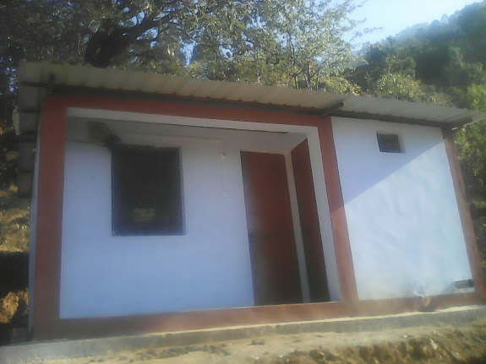
Village | Institute | Member | Mob. No. | Cost of housing
Mishar gown(Gram panchayat) | Sahara Christian Academy | 1-Mr. Stephan(manager)  2-Mr.sharma(supervisor)  3-Mr. Umashankar(DGM) | 8591000896  9310597505  8979455724 | 250000

In this way by the support and proper information of dgm umashankar built house by “sahara Christian academy” for helpless and houseless villager mr. Kiritibhushan.
2-Bridge Between Two Gram panchayat MIshar gown and Bhatwari dhanari:-
Further continuing his work of “samaj soochak” mr. umashankar felt very important need in Gram panchayat mishar gown and bhatwari. The Bridge which link two Gram shabha destroyed by flood of natural disaster jun-2013. The villagers of both panchayat facing great problem after destroying bridge. Mr. umashankar(dgm) collect villager and told them that the visiting of MLA(member of legislative assembly) and he himself face to face talk with MLA and request to give first priority bridge construction. Then MLA declared 12 lakh amount for bridge construction.
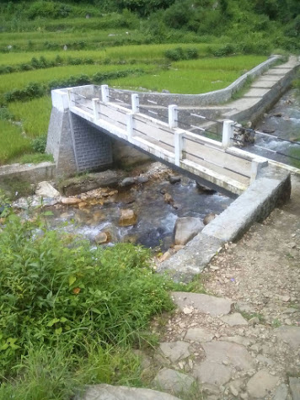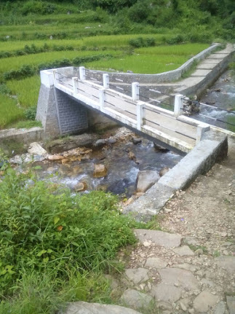
Villages | Beneficiary | Member/contractor | Mob.No | Funding By
Vill-Mishar gown  Vill-Kuleth  Vill-Bhatwari dhanari | Villager of two gram panchayat | 1-Mr. VS sajwan(Gangotri Member of legislative assembly cabinet level)  2-mahendar singh(contractor vill Kuleth) | +91-9412050899  +91-8126671081 | MLA  (member of legislative assembly)Fund

3-DGM Pawna Gram sabha Matli(Supporting wall construction) and giving banifit of nada devi kanya dhan yojna-
Dgm mrs. Pawna working as Drishtee gram mitra “samaj soochak” in gram shaha matli. She is by nature good activist as well as helping nature. In this project of “Soochna aapke dwar” she made her well effort by providing proper information of identified needs of family. Further in this process she has done good work in village for both individual and community basis. She put proposal by needy family and villager to Gram Pradhan Chandra kala saha Matli for Supporting wall from MNREGA schemes.
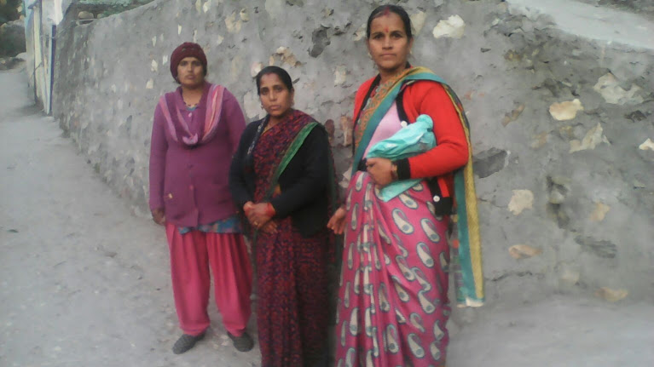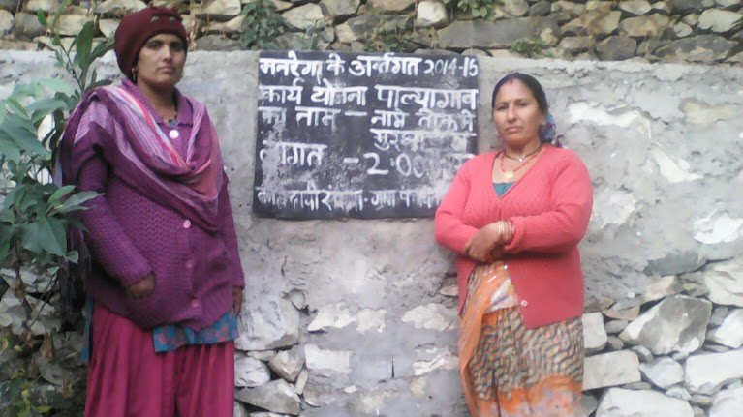
Suporting wall Inspection by Dgm pawna, Dgm laxami and Gram pradhan Chandar kala sah.
Village | Public member | Funding by | Beneficiary | Total cost
Gram panchayat Matli | Gram pradhan-Chandar kala sah mob.no 8057417796 | MNREGA(supporting wall) | Villagers | 2 lakh
Gram panchayat Matli | Gram pradhan-Chandar kala sah mob.no 8057417796 | MNREGA(supporting wall) | Villagers | 1lakh

In month sep-2015 Dgm pawna gave Information of “Nada devi kanya dhan Yojna” which is currently executing by the Dept. ICDS(Integrated child development service) Uttarakhand. In this scheme is for those female Childs whose Date of birth after Dec.-2009. They can take advantage of this scheme.
In this way Dgm pawna went to door to door and find out eligible villagers whose daughters take birth after Dec.-2009, and explain them all criteria and formalities to submission form. After completing documentation formalities she went with them Block office of ICDS dunda, and submitted all Forms of “Nanda devi kanya dhan yojna”.
Beneficiaries Details given below:-
Nanda Devi kanya dhan Yojna
Vill/Panchayat | Family head | Mob. No | Beneficiaries | Total Amount
Matli | Vijay | 9410385039 | richa d/o seema | 15000
Matli | gambheer singh |  | khushi d/o manisha | 15000
Matli | Rajesh | 9997501306 | jahanvi d/o saraswati | 15000
Matli | Rajpal | 8126642304 | paridhi d/o parvati | 15000
Matli | Arvind |  | sreshtee d/o gajendri | 15000
Matli | Deepak | 7895716683 | vashnavi d/o mamta | 15000
Matli | roshan | 8126355423 | aarushi d/o geeta | 15000
Matli | Premlal | 9756696231 | Anshik d/o rajni | 15000
Matli | Sumit |  | vashnavi d/o kanchan | 15000
Matli | Vijay | 7895721871 | khusi d/o kanchan | 15000

Same this way our Drishtee Gram mitra Mrs. Laxami currently working in Vill/panchayat Badethi.By her good effort she properly guide and give information to eligible villagers of vill-Badethi. And she has good relation with panchayat and villager. During survey she find out some beneficiaries of ICDS scheme “Nanda devi kanya dhan yojna” and told them to complete all formalities of form submission in Block office Dunda.
Beneficiaries Details given below:-
Nanda Devi kanya dhan Yojna
Vill/Panchayat | Family Head | Mob. No | Beneficiaries | Total Amount
Badethi | Jaibeer | 7895857477 | Anuska d/o vinita | 15000
Badethi | manveer | 9927991691 | anuska d/o vijaylaxami | 15000
Badethi | gyanesh | 9897808366 | gitika d/o shoba | 15000
Badethi | Ankush | 8449337683 | somya d/o mamta | 15000
Badethi | anand pal | 9756228781 | anamika d/o sona devi | 15000
Badethi | pravesh | 9634225140 | sonakshi d/o rinita | 15000
Badethi | Dinesh | 9411748208 | veshnavi d/o uma | 15000
Badethi | anand pal |  | manisha d/o sona | 15000
Badethi | hardayal |  | samiksha d/o ramkali | 15000
Badethi | Dinesh | 9411748208 | aiesha d/o veena | 15000
Badethi | panchram | 9412439901 | upasna d/o kosha devi | 15000
Badethi | sudheer | 8449285189 | anamika d/o kumita | 15000
Badethi | pratim singh | 7409988941 | laxami d/o urmila | 15000
Badethi | Suresh | 8155698373 | divyanshi d/o suchita | 15000
Badethi | Rampal | 7895713528 | avantika d/o vandana devi | 15000
Badethi | narendar singh |  | aaradhya d/o vinita | 15000
Badethi | Gopal |  | ishani d/o babita | 15000
Badethi | chandara pal |  | aaradhya d/o kiran | 15000

4-Gram sabha Birpur Dunda(Drishtee gram mitra-SUNITA) Giving benefit by “Mewar University and Motherhood University of Degree courses for ST & SC candidate.
Drishtee gram mitra(DGM) Mrs. Sunita working as dgm in gram panchayat Birpur dunda.
She is good activist as “samaj soochak” and fully energetic for his work. Generally she has been working for previous year but in month middle oct-2015 she has got best achievement for her work as drishtee samaj soochak. She has enrolled 8 SC & ST candidate of for degree/diploma courses from “Mewar University and Motherhood University” through distance education. And she also requested to chair man of University about learning and examination center must be in Uttarkashi distt.
This information she gained from coordinator of university named SUSHANT, in month oct-2015 mr.Sushant has come in Dunda, Uttarkashi. At this time mrs. Sunita meet him and discussed about the plan of university. Mr. Sushant explained her that “Mevar University offered some courses B.Ed, M. Sc Com. Sc., MBA, B. Lib., M. Lib. MSW etc for those SC & ST graduate candidate whose economict is poor and they cannot bear these expensive courses fee.
After gained complete knowledge about these courses then she went to search for eligible candidate of Birpur dunda and also share this information with another DGM. And tell them that candidate who has eligibility for the one of above courses, Income certificate, graduation degree, migration must be attached in application form
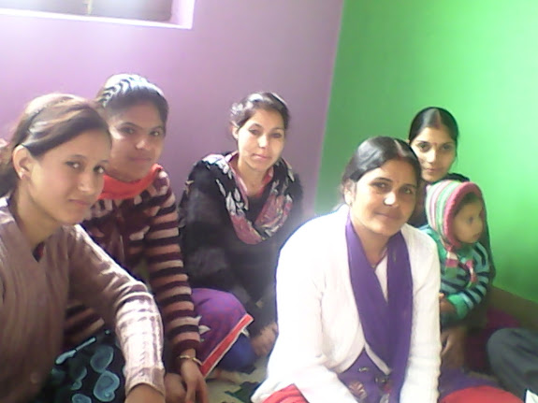.
Enrollment date and Fee detail given below(Village/panchayat Birpur Dunda:-
These courses offered By “Mewar & Motherhood University for “SC & ST Candidate” Free of cost.

Family Head | Mob. No | Course/University | Beneficiaries | Fee
dinesh chandra | 8938910957 | MSW(from Mewar University) | Suneeta | 60000
shiv ram |  | M.sc Com.Sc.(Mewar university | Pinky | 60000
gopal singh | 8057066696 | MSW(from Mewar University) | Susheel | 60000
gopal singh | 8057066696 | BBA(from mewar university) | Sushma | 60000
Kapoor singh | 9568105083 | B.Ed(from Motherhood University) | Laxami | 90000
laxami chand | 8979978481 | B.Ed(from Motherhood University) | Sabnam | 90000
kamla devi |  | B.Ed(from Motherhood University) | Pinky | 90000
madan mohan |  | B.Ed(from Motherhood University) | Sarita | 90000

These above degree courses are offered by “Mewar and Motherhood University” for only “SC & SC candidate of Uttarkashi distt. free of cost.

Hereby Further we hope for gaining best achievement by our team of Dunda Block.

